Since 2006.

Grape Technologies
  - be different.


What is Grape Technologies?
Grape Technologies , is a Consumer Electronics and Technologies Start-up that’s dedicated to giving Africans, a great technological identity, the standard of technology not only in the region, but in the world through advancement of existing technologies present In Africa , and developing new ones, in the sights of generating the technology of the future.

What does it believe in?
Grape Technologies gives itself up to this identity, to this grand image, to this future and is dedicated to this making of a unique ,technologically advanced, different, Africa.

We draw great inspiration from YOU who does their daily tasks in the African Environment which we all know is sometimes harsh and unforgiving, affecting and varying your degrees of success in your varying fields of passion and industry, and we believe that the task is at hand to easen and enhance your grind and easen your lifestyle , focusing on you , enhancing your use with your daily devices, enhancing your productivity, pushing forward the future , which we believe is driven by YOU!

What makes us different from others is that we take pride and inspiration from Africa iself ,and its sights and sounds, and becomes the tech company that delivers that beauty to the world.

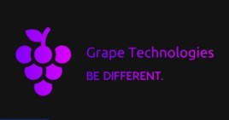

Nairobi, Kenya.
+254740105464 (talk to the founder)
www.grapetechnologiesforum.com

